Project Design Phase-II

Data Flow Diagram & User Stories

|  |  |
| --- | --- |
| Date | 28 June 2025 |
| Team ID | LTVIP2025TMID28937 |
| Project Name | Cafeteria menu display |
| Maximum Marks | 4 Marks |

# Data Flow Diagrams:

A Data Flow Diagram (DFD) visually represents the flow of data within a cafeteria management system, illustrating how information is processed from input to output. It helps in understanding the system's functionality, identifying potential issues, and designing the software architecture.

**1**. **Entities and Processes**:

*Entities: These are the external elements that interact with the system, such as students, cafeteria staff, and administrators.

* Processes: These are the actions performed within the system, like placing an order, processing payment, preparing food, and generating reports.

**2. Data Stores:**

* These are repositories where information is stored and accessed, such as a database of student information, menu items, inventory, and transaction records.

**3. Data Flow:**

* The DFD shows the movement of data between entities, processes, and data stores. For example, a student's order data flows from the student to the ordering process, then to the kitchen for preparation, and finally to the student as a receipt.

# Example:-

# A basic level-0 DFD (context diagram) for a cafeteria management system might include the following:

# *External Entities: Student, Administrator

# * Processes: Order Management, Inventory Management, Payment Processing, Reporting

# * Data Stores: Menu Database, Student Database, Transaction Database, Inventory Database

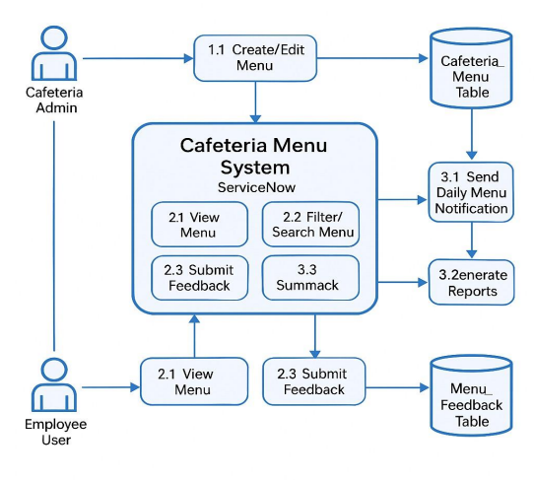

**User Stories**

Use the below template to list all the user stories for the product.

|  |  |  |  |  |  |  |
| --- | --- | --- | --- | --- | --- | --- |
| **User Type** | **Functional Requirement (Epic)** | **User Story Number** | **User Story / Task** | **Acceptance criteria** | **Priority** | **Release** |
| Admin User | Studio | USN-1 | As a admin, I can create studio in service now  using my login credentials | I can access my account /  dashboard | High | Sprint-1 |
| Admin User | Table | USN-2 | As a admin, I can create table for cafeteria menu display in servicenow | I can receive confirmation email & click confirm | Low | Sprint-1 |
| Admin User | Service Catalog | USN-3 | As a admin, I can create service catalog in servicenow using my credentials | I can register & access the dashboard with  Servicenow Login | High | Sprint-1 |
| Admin User | Reports | USN-4 | As an admin, I can make a report for the project through the service now |  | Medium | Sprint-1 |
| Admin User | UI Actions | USN-5 | As an admin, I will create UI actions for the project using my login credentials in service  now |  | High | Sprint-1 |
| Admin User | Testing | USN-6 | As a admin, I can test the service catalog and ui actions through the service now |  | Medium | Sprint-1 |